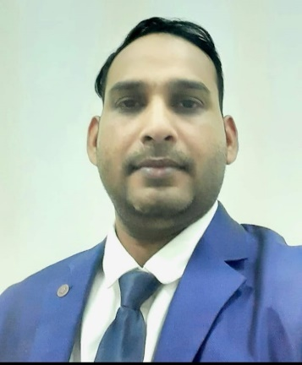

**Director**

**AK. SIR**

**MR. ASHFAK ANSARI**

**(HOD ENGLISH & GLOBAL PLACEMENT)**

*(M.A. English American Literature*

*Global Manager, Chicago, USA*

*PG in Marketing & Sales Management)*

**Message**

“*I experienced during my practical life these four keywords (CKPP) which always stands out your skill outstanding. Follow these and you will be adorned with great success.”*

*C- Confidence*

*K- Knowledge*

*P- Patience*

*P- Positivity*

***-AK. SIR***

**About**

Greetings to all my readers and viewers. I belong to a medium family and was born in a village Sauna Lachhuman in the district of Deoria primarily known as Deoghar in the state of Uttar Pradesh, India.

I got my primary education from my village primary school Sauna Lachhuman and had immense interest in speaking and learning English since my those days. My father was also B.Sc. Mathematics and always used to focus and tell the importance of knowledge. He used to provide all the supplies especially studies’ materials. I have been remarkable student in English from primary till Master of English. Never counted the marks in my result, I have been an excellent learner and speaker of English with grammatical orders. Till my Junior School 8th standard, I had finished all the terms of English Grammar.

During graduation from DDU University, Gorakhpur , I used to hold tuition from 9th to 12th and even the graduate students. I used to teach the students of all the boards CBSE/ICSE and UP as tuition under the name of MM Tutorials which was run by our brothers MJ Sir, MR Sir and me.

Later, I resolved to open a CBSE school and ultimately it was established in 2012 under the name of KNOWLEDGE KING ACADEMY. We all four brothers have been expert in different subjects as we confess this gift, the mercy and grace of God. One of my brothers MJ Sir has been expert in Chemistry, Biology and Physics too. The second one MR Sir has been expert in Mathematics and Physics. My elder brother IT Sir has been expert in Computer and IT. Me myself have been expert in English and Social Studies. So we have a complete competitional faculty for all the subjects. Since 2012 to 2018, only one institute was famous in the town of Hata, Kushinagar. We run super thirty batch and educate them well and minute mechanism of teaching methods. All my students were secured 100% CGPA for nearly all the super thirty batch.

Further, I was selected as Area Busines Manager Burger King Company , Miami , Florida, USA under the franchise of KSA ( Kingdom of Saudi Arabia). I used to manage there citizens of multi nationalties which was really an enthusiastic for me to be represent as global manager with only the power of fluent English and logic which is my god gifted virtue. Always I have seen the impossible dream. Really I feel excitement to gain unachievable goal. Either you fail or learn, Never defeat. Defeat is your death only. Nobody can perform greatness after his/her death so live freely and think freely during this mortal life.

Presently , It was observed that new abode of education has been replaced for the old method of physical chalk-board teaching method. Now-a-days degree is easier than to getting knowledge. So this is my message to all my dear readers to be smarter than hard worker. Smarter in the sense of swiftly observing the facts and storing into the mind with accuracy.

***Join KNOWLEDGE KING EDU PVT LTD for career/degrees/certificates/knowledge/training/job placement and entire education solution relevant to your skill and calibre. We shape your career at all.***

***Thank you to all.***